Winter Coat Store

SE352 – Object Oriented Enterprise Application Development

Come wrap in warmth

Contents

Overview 2

Requirements 2

Use Case 2

Description of problem 2

Design 3

Sequence of major functionality 3

Web UI (Common case) 3

Table layout 3

Deployment 3

Discussion of how your design met the requirements 3

Discussion of lessons learned 4

Decision Log 5

Milestone Screenshot 6

# Overview

An online winter coat shop that allows the user:

* Search for winter coat stores by the use of zip code
* Register for a winter coat raffle
* Add coats to shopping cart

# Requirements

## Use Case

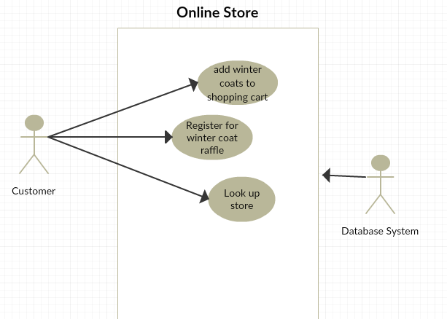

## Description of problem

Online winter coat store that supports human interaction using the Internet. Users can search for winter coat stores by zip code, register for a winter coat raffle, and add a winter coat to a shopping cart.

# Design

## Sequence of major functionality

### Web UI (Common case)

Here I would replace calculatorOperation with winterCoatOperation and CalculatorBean with WinterCoatBean.



## Web UI Mockup

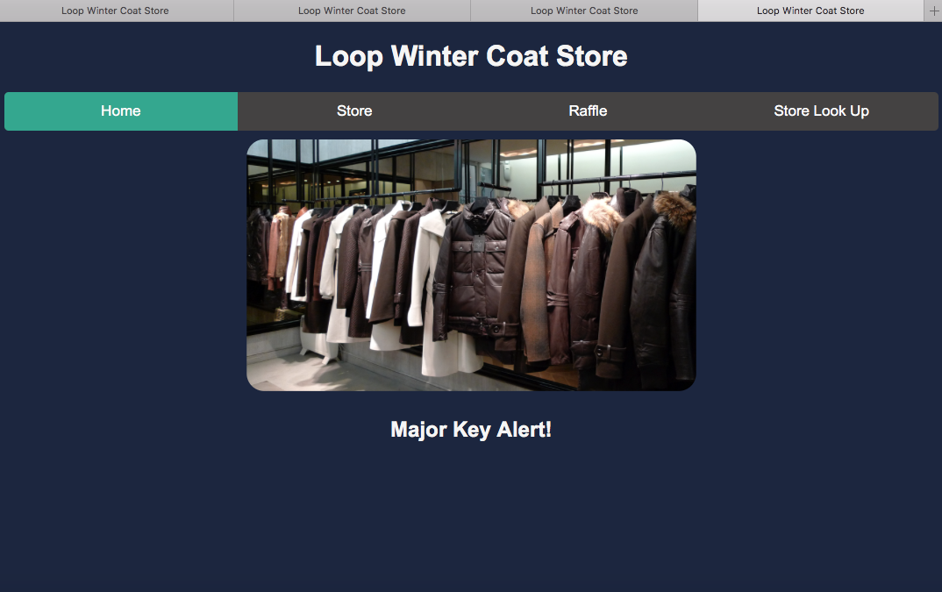

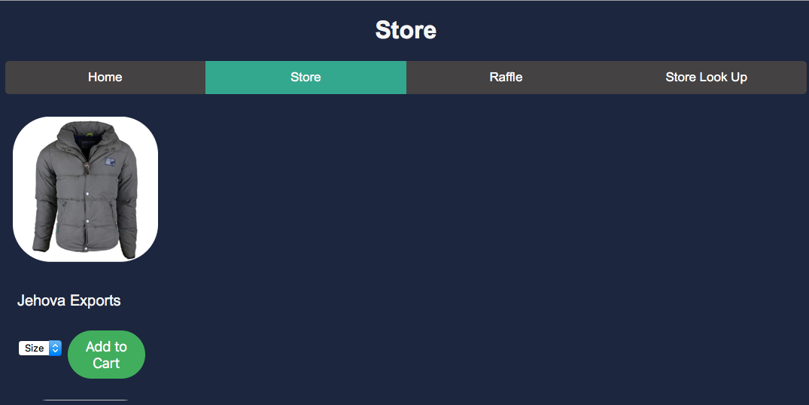

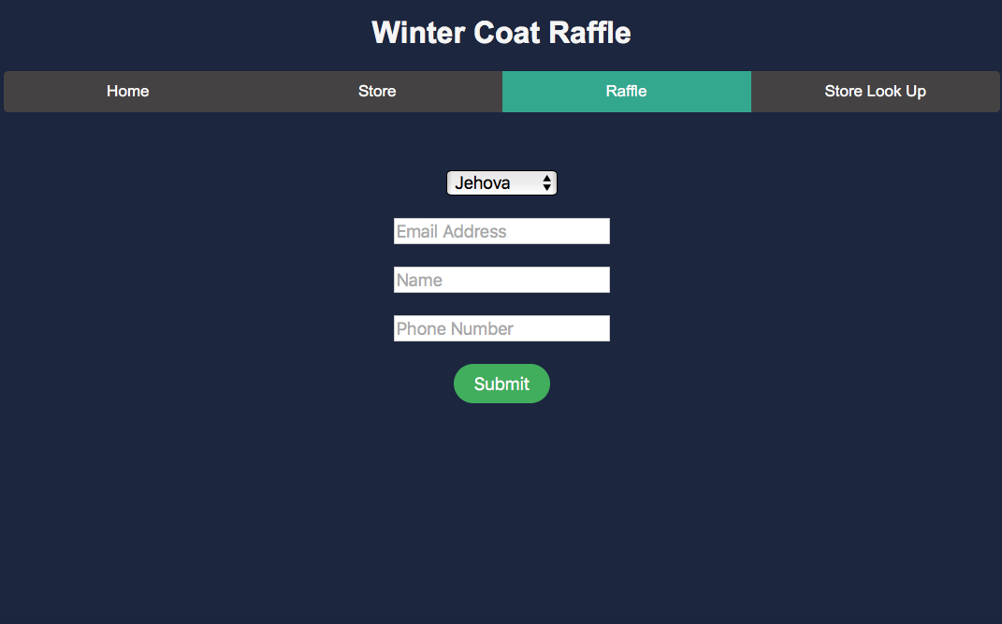

## Macintosh HD:Users:michaelalarcon:Desktop:Screen Shot 2018-11-14 at 9.10.33 PM.png

## Table layout

**NoSQL Document**

Winter Coat Store table

|  |  |  |  |  |
| --- | --- | --- | --- | --- |
| ID | Name | Street | City | Zip |
|  |  |  |  |  |
|  |  |  |  |  |

One document to fulfill the requirements to register for the winter coat raffle.

**SQL Tables**

|  |
| --- |
| **WinterCoat** |
| Id |
| Name |
| Brand |
| Color |
| Size |
| Type |
| Price |
| Gender |

|  |
| --- |
| **Customer** |
| Raffle Id |
| Shoe Id |
| Name |
| Email |
| Phone number |

There’s two tables to fulfill the requirements to register for the winter coat raffle.

Winter Coat table

|  |  |  |  |  |  |  |  |
| --- | --- | --- | --- | --- | --- | --- | --- |
| ID | Name | Brand | Color | Size | Type | Price | Gender |
|  |  |  |  |  |  |  |  |
|  |  |  |  |  |  |  |  |

Shopping Cart

|  |  |  |
| --- | --- | --- |
| Order number | Sneaker Id | Quantity |
|  |  |  |
|  |  |  |

There’s only two tables that fulfill the requirement of adding winter coats to a shopping cart

## Deployment

All the classes were packaged into one jar file to keep things simple.

The project is integrated with TravisCI, a continuous integration software that builds the project after each commit and makes sure that it’s not a broken build that’s being committed.

# Discussion of how your design met the requirements

Customers can add winter coats to their shopping cart, they can see what items they have in the shopping cart, enter their information for a winter coat raffle, and also look up stores by using a zip code. **Note:** If you want to test the store use Zip codes 60603, 60604, 60605, 60647.

# Discussion of lessons learned

**SQL Database decision**

The use of an SQL database for the shopping cart functionality and store finder was decided. Reason I decided to use the SQL database for the shopping cart was for consistency. With the sneaker raffle it will allow the sneaker table to be joined with the customer table, this will find all the customer information with the specific winter coat they fill the raffle ticket.

**NoSQL Decision**

MongoDB was used as the database for the store look feature because it would be quick if the user just passes a zip code, it can find the documents that have the same zip code.

# Decision Log

|  |  |  |  |
| --- | --- | --- | --- |
| **Problem** | **What was decided** | **Alternatives considered** | **Rationale** |
| Which IDE to use | IntelliJ | Eclipse | IntelliJ had all the components integrated in one UI |
| SQL Database | PostgreSQL | MySQL | Open source and I’ve worked with PostgreSQL |
| NoSQL Database | MongoDB | Fire Base | Fast access to Database and can modify the data from database UI |
| Code repo | GitHub | Local Machine | I would be able to have access to the code in any computer |
|  |  |  |  |
|  |  |  |  |

